Name: ______________________________________ | Date: ___________________

Stakeholder Feedback Form

Part 1: Preparing for Feedback

When getting ideas from stakeholders, it can be easier to start off by asking them what thoughts they have about criteria or constraints for existing designs or problems that do not yet have designs that meet the need of protection, before sharing any of your own ideas.

Step 1: Complete the chart below to determine what you will ask your stakeholders.
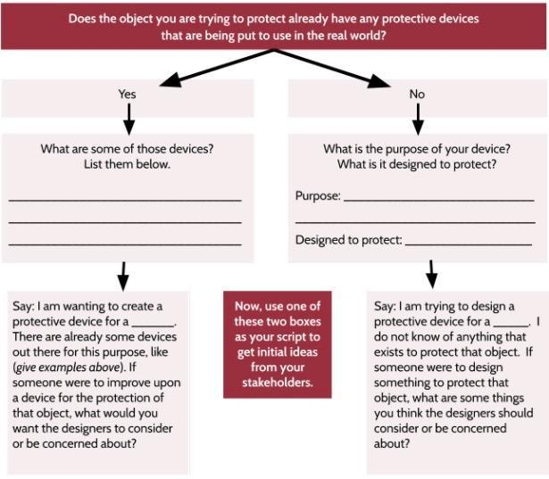

Step 2: Think about your protective device design. When you created your draft, you made trade-offs. Summarize why you made those trade-offs. List them in the table below.

Trade-off | Why you decided to make this trade-off

Part 2: Home Learning

Step 3: Read the script from step 1 to someone you have identified as a stakeholder. Record below what your stakeholder lists as concerns or additional design considerations. If you want, you can ask more than one stakeholder for different perspectives.

Step 4: Share your design with the stakeholder. Look back at step 2 and explain the trade-offs you have made in your design. Ask your stakeholder what additional trade-offs they want you to consider and ideas they have to improve your design. List them below.

Additional trade-offs to consider | Ideas for design improvement

Step 5: Ask your stakeholder for an honest product review and to explain why they would or would not purchase this product. You are welcome to give this paper to your stakeholder for them to write in this area. Ask them to be nice but honest about any areas for improvement since we want to use this review to help optimize our designs.

